Contents

1.0 Introduction 1

1.1. Setting 1

1.2. Scene flow 1

2.0 Project plan 2

2.1. Initial Project Plan 2

2.2. Week 1 6

2.3. Week 2 8

2.4. Week 3 9

2.5. Week 4 11

2.6. Week 5 14

2.7. Week 6 16

3.0 Technical Element - Vectors 17

3.1. Introduction 17

3.2. Uses in Video Games 17

3.2.1. Main uses 17

3.2.2. Movement 17

3.2.3. Distance 18

3.2.4. Other Uses 18

4.0 Script 19

5.0 Unique Element 20

6.0 Summary 21

7.0 Future Work 22

8.0 References 23

8.1. Github 23

8.2. Assets 23

8.2.1. Models 23

8.2.2. Audio 23

8.2.3. Fonts 24

8.2.4. Sprites 24

8.2.5. Scripts 24

8.2.6. Full References 24

9.0 Appendix 28

# Introduction

## Setting

The scene will start with the player outside in a forest in a perpetual foggy night cycle with a spooky house in front of them, they will then approach the house triggering a floodlight. Upon entering the house the front door will lock and they will have to complete the following steps to escape the house and trigger a daytime cycle, completely changing the mood of the scene

## Scene flow

1. Approach house triggering a floodlight.
2. Enter house and doors lock – loud clock ticking.
3. Cuckoo clock goes off when nearby dropping the cuckoo.
4. Carry the cuckoo up stairs.
5. Enter bedroom, bedroom door locks.
6. Throw the cuckoo in the bedroom fire increasing intensity – A vase appears.
7. Pickup bathroom key from the bedside table.
8. Exit bedroom via the en-suite bathroom.
9. Throw the vase down the stairs, smashing it to reveal lounge key.
10. Enter the lounge – piano starts playing spooky music loop.
11. Pick up the fruit bowl.
12. Approach the lounge fire – Tv comes on.
13. Throw the fruit bowl in the lounge fire, increasing intensity and melting candle. – Kitchen key appears.
14. Enter the kitchen – serving hatch doors start clattering
15. Exit the kitchen to the conservatory.
16. Collect the conservatory key from the pool table.
17. Exit conservatory triggering daytime.
18. Display Message – “You escaped!”

# Project plan

## Initial Project Plan

Below is my initial project plan (Figure 2.1) on Trello (Atlassian, 2021) which is available at the following link - <https://trello.com/b/x2qX9eYN/p3d-asignment>.

All expandable cards are also shown below (Figures 2.2 – 2.7)

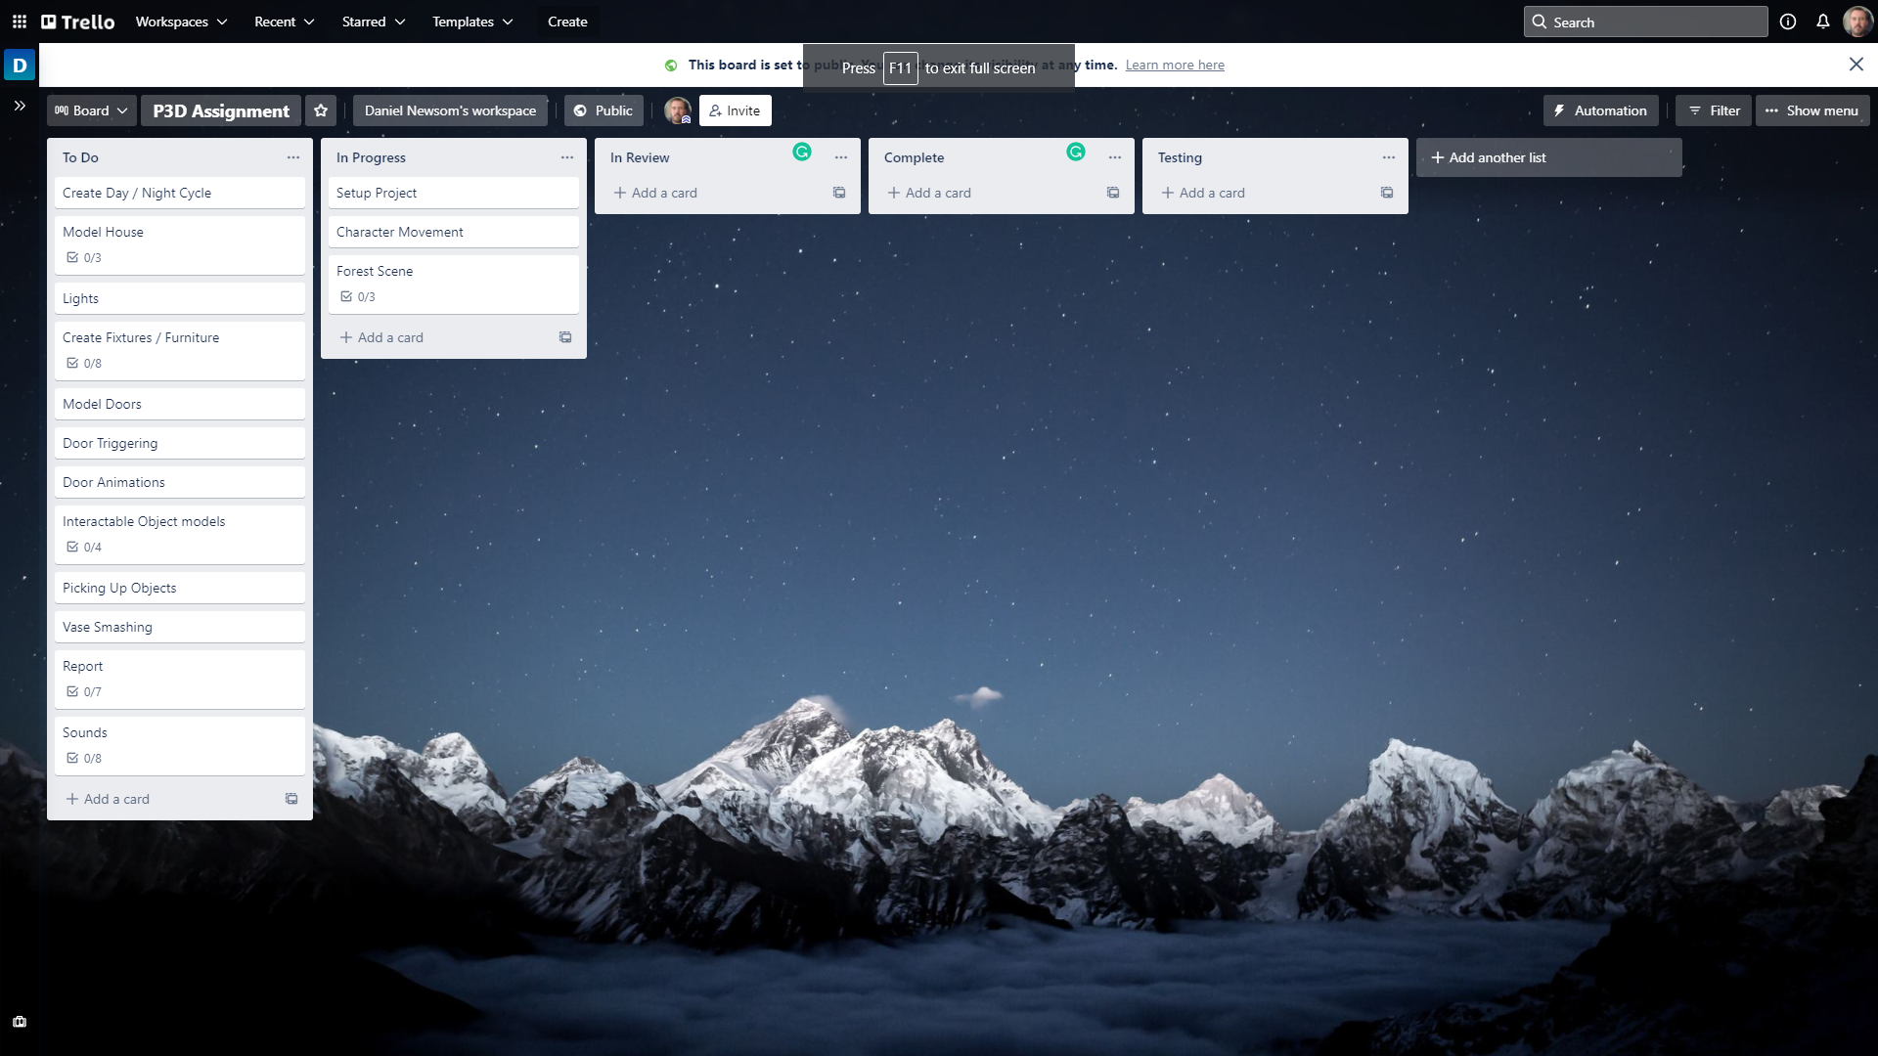

Figure 2.1 – Initial project plan on Trello (Atlassian, 2021)

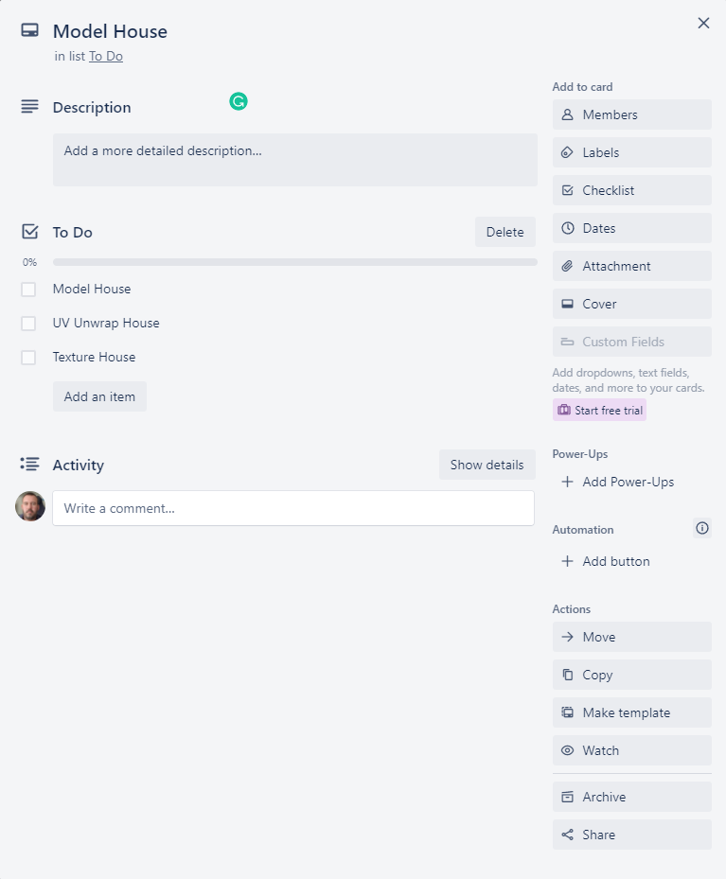

Figure 2.2 – Model house card

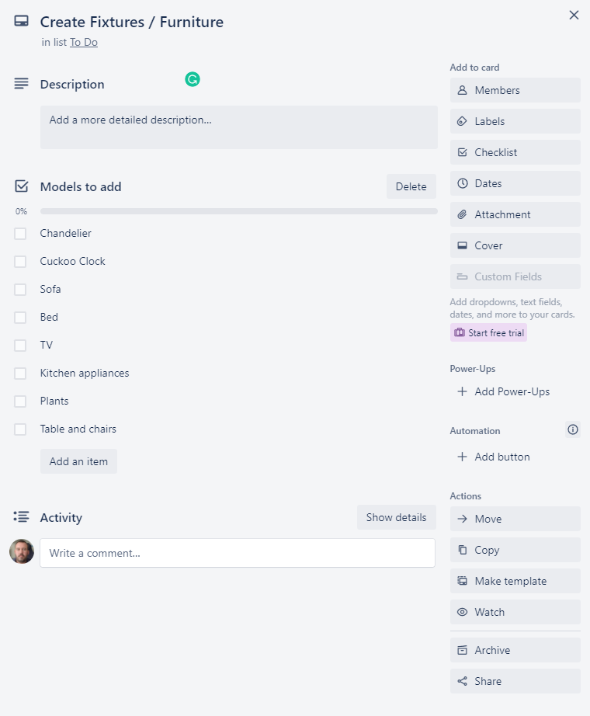

Figure 2.3 – Create Fixtures / Furniture card

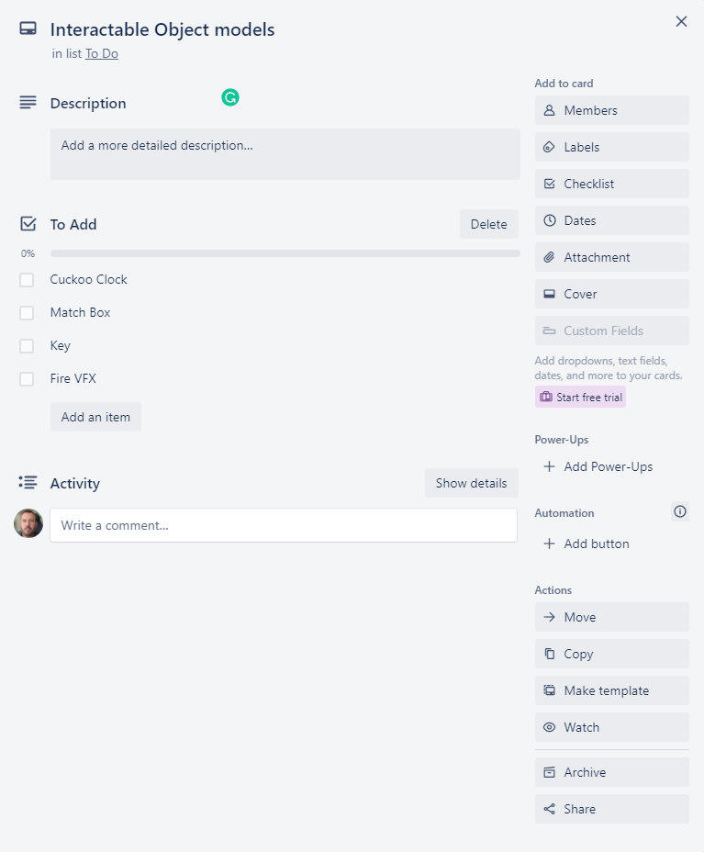

Figure 2.4 – Interactable Object Models card

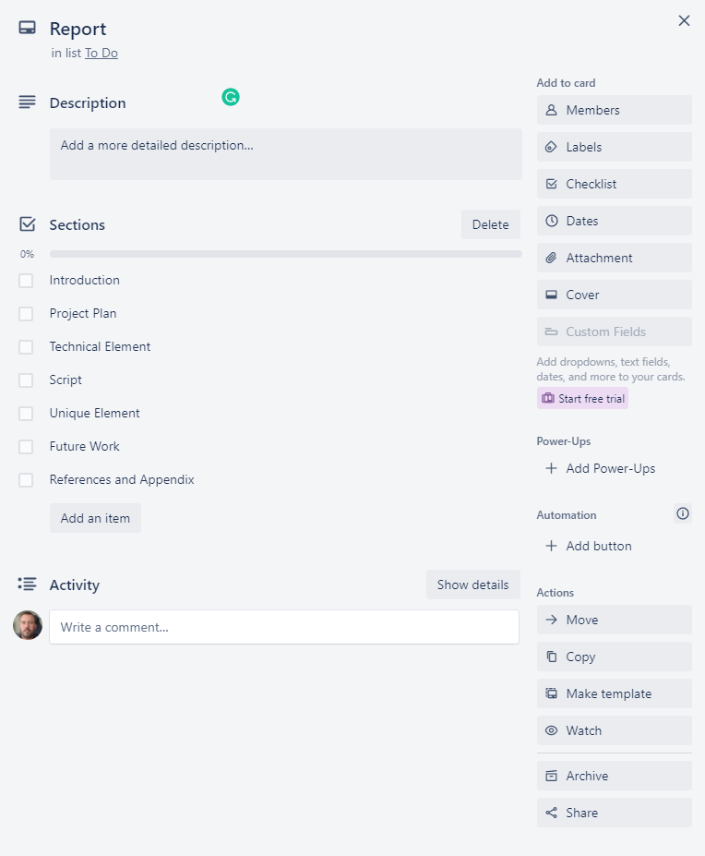

Figure 2.5 – Report card

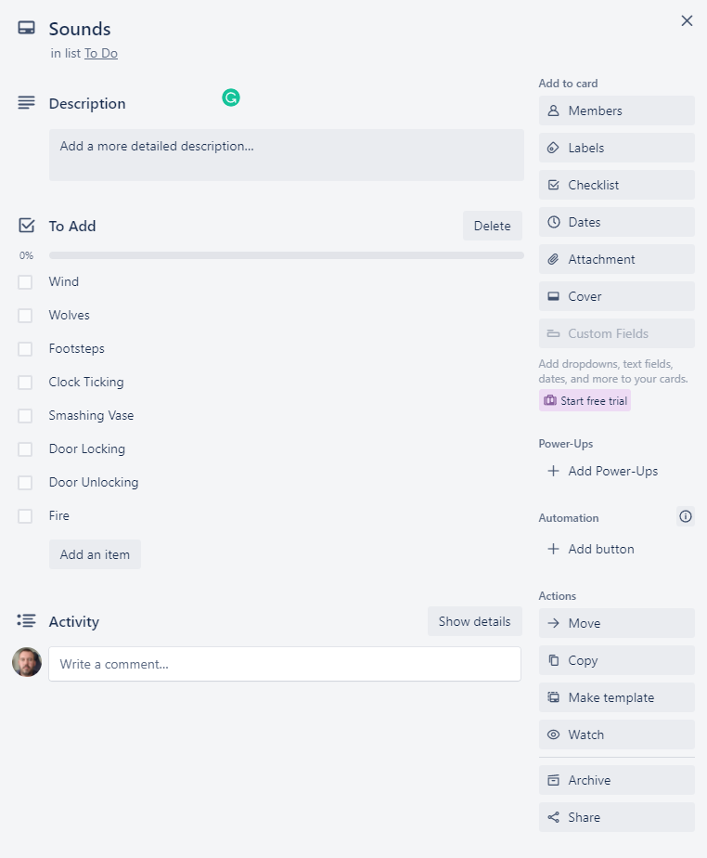

Figure 2.6 – Sounds card

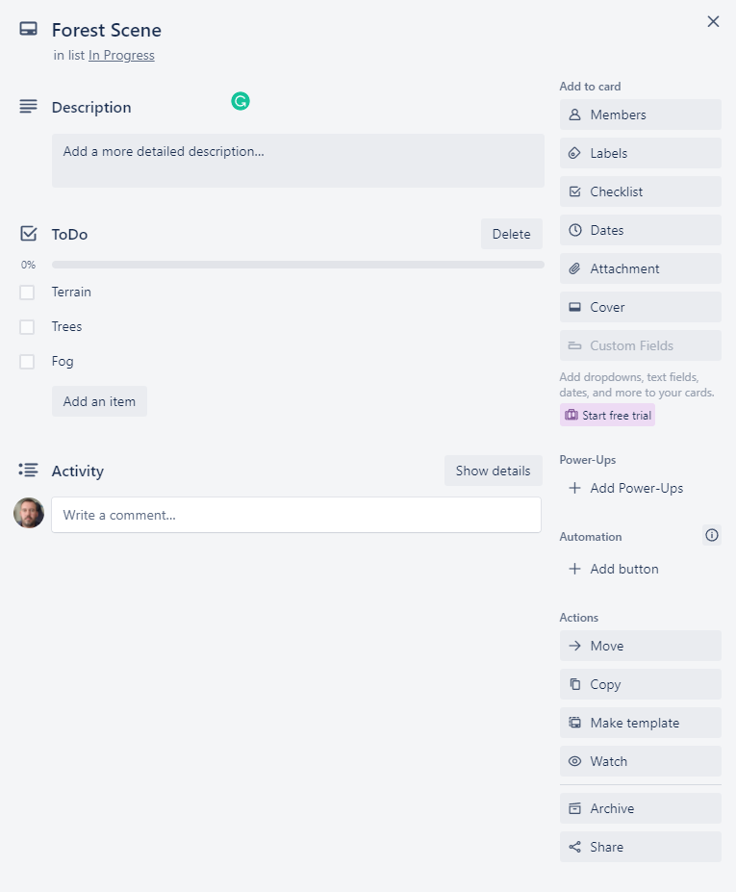

Figure 2.7 – Forest Scene card

## Week 1

The plan for week 1 is as follows

* Setup the Unity (Unity, 2021) project using the high definition render pipeline (HDRP).
* Create the main scene and add a Terrain.
* Paint textures on the terrain from the Forest Environment - Dynamic Nature (NatureManufacture_Forest_Environment, 2021) asset pack.
* Add Trees on the terrain using the Mountain Trees - Dynamic Nature (NatureManufacture_Mountain_Trees, 2021) asset pack.
* Implement the characters movement using the Starter Assets - First Person Character Controller (Unity_Starter_Assets, 2021) as a base to build upon.
* Start Modelling house using Blender (Blender, 2021)

The updated Trello (Atlassian, 2021) board at the end of week 1 is shown below (Figure 2.8) as well as the relevant expanded forest scene card (Figures 2.9) and report card (Figure 2.10).

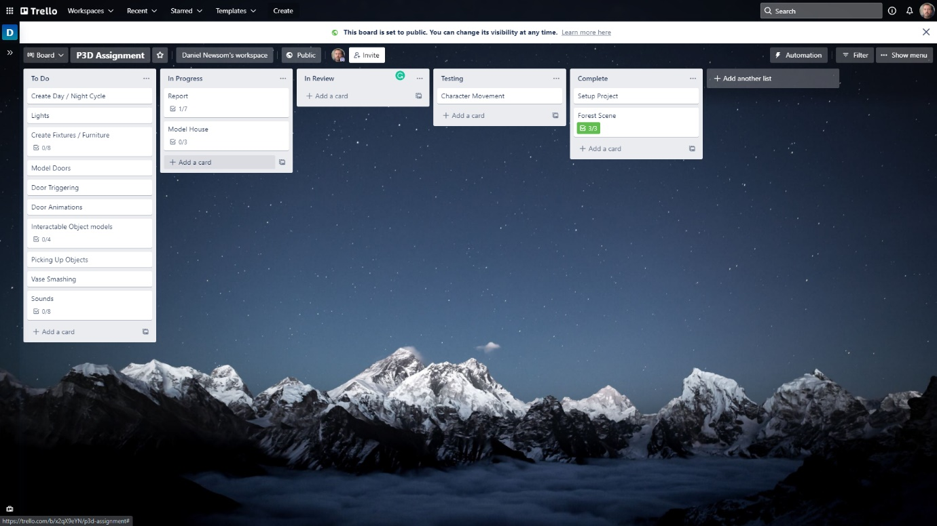

Figure 2.8 – Trello (Atlassian, 2021) board status at the end of week 1

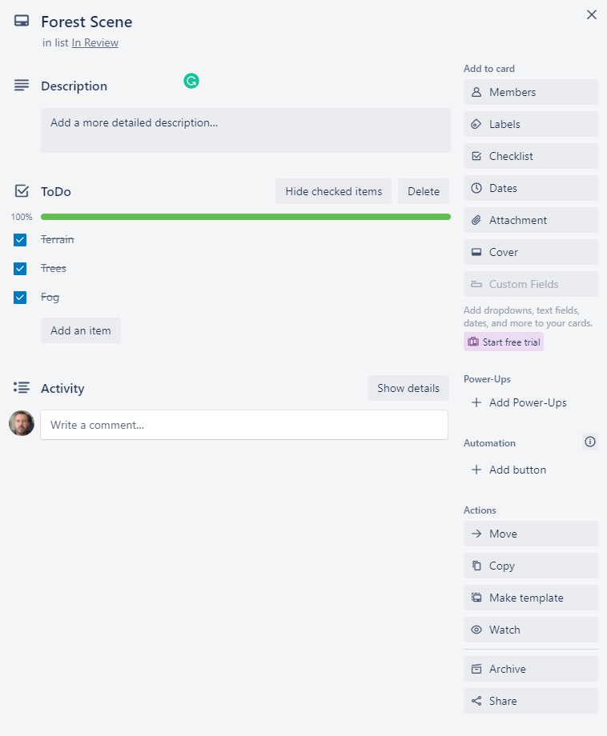

Figure 2.9 – Forest scene card updated

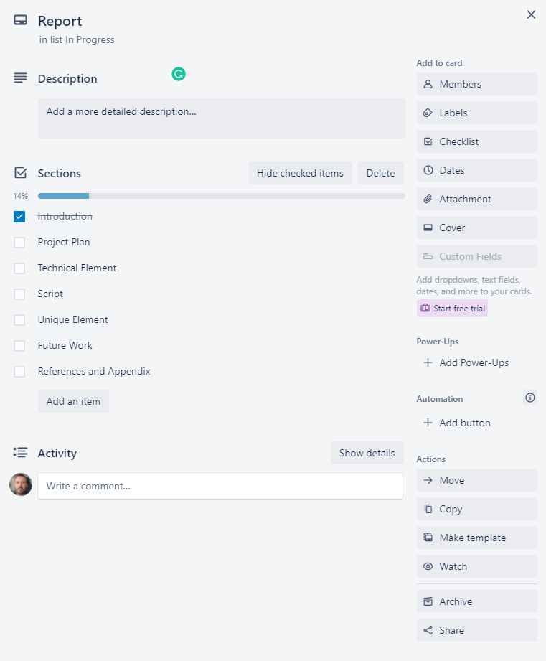

Figure 2.10 – Report card updated

## Week 2

The plan for week 2 is as below

* Finish modelling the house
* UV unwrap the house
* Add textures and materials to the house model
* Model the doors
* Animate the doors
* Add trigger scripts to the doors

The updated Trello (Atlassian, 2021) board at the end of week 2 is shown below (Figure 2.11) as well as the relevant expanded model house card (Figures 2.12)

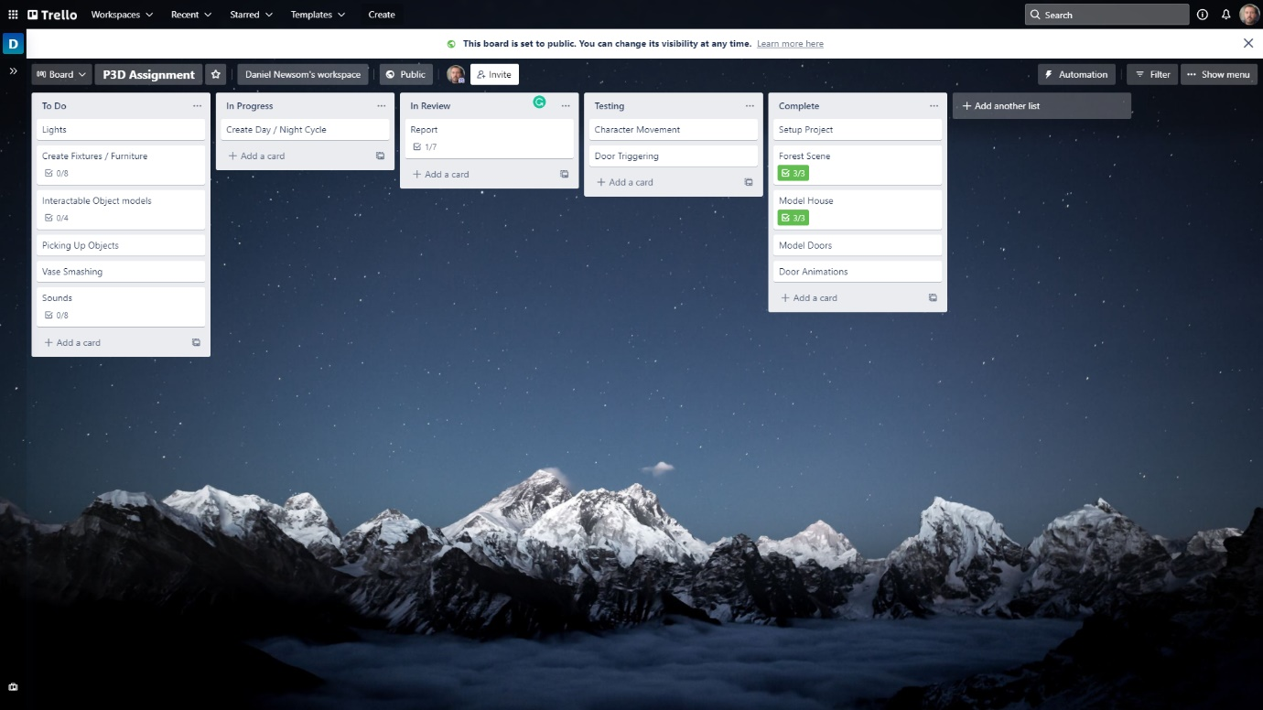

Figure 2.11 - Trello (Atlassian, 2021) board status at the end of week 2

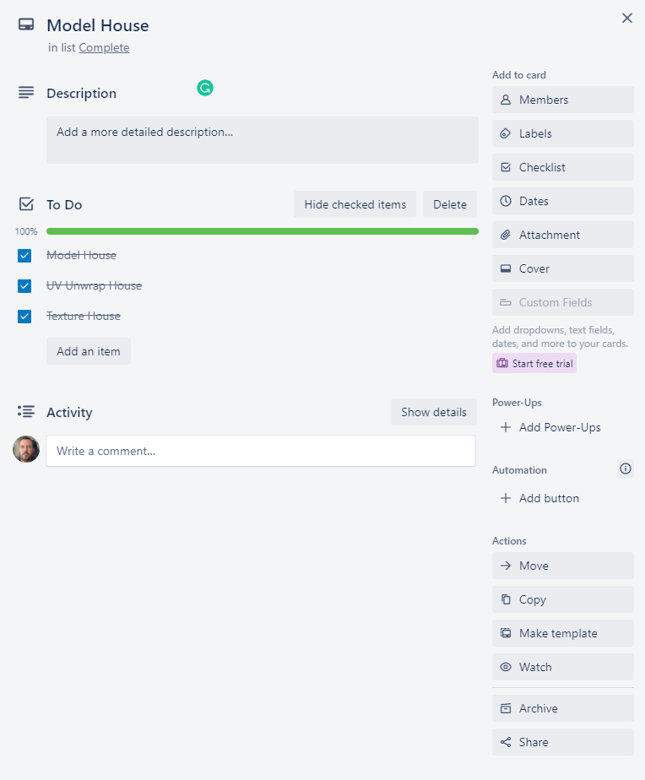

Figure 2.12 – Model House card expanded

## Week 3

The plan for week 3 is as follows

* Re-write introduction section of report
* Add chandelier model
* Animate chandelier model to sway
* Add light models to all other rooms
* Add / adjust lights to light models within Unity (Unity, 2021)
* Refactor Character controller script
* Start Day / Night Cycle animation and trigger.

The updated Trello (Atlassian, 2021) board at the end of week 3 is shown below (Figure 2.13) as well as the relevant expanded create fixtures / furniture card (Figures 2.14).

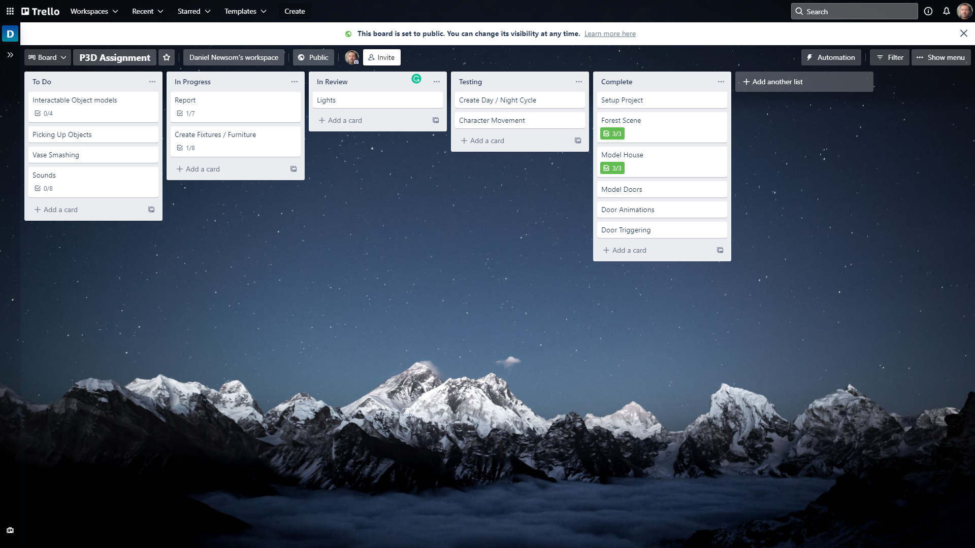

Figure 2.13 - Trello (Atlassian, 2021) board status at the end of week 3

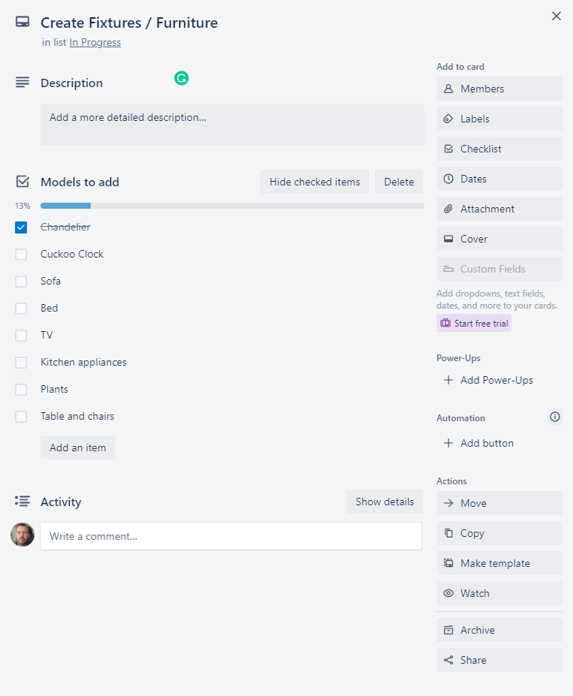

Figure 2.14 – Create Fixtures / Furniture card expanded

## Week 4

The plan for week 4 is as follows

* Model / add Interactable objects
* Start adding furniture (Priority Cuckoo clock)
* Implement picking up / using / throwing objects
* Add VFX fires and triggers
* Start adding sounds.

The updated Trello (Atlassian, 2021) board at the end of week 4 is shown below (Figure 2.15) as well as the relevant expanded Interactable Object models (figure 2.16), create fixtures / furniture card (figures 2.17) and Sounds card (figure 2.18).

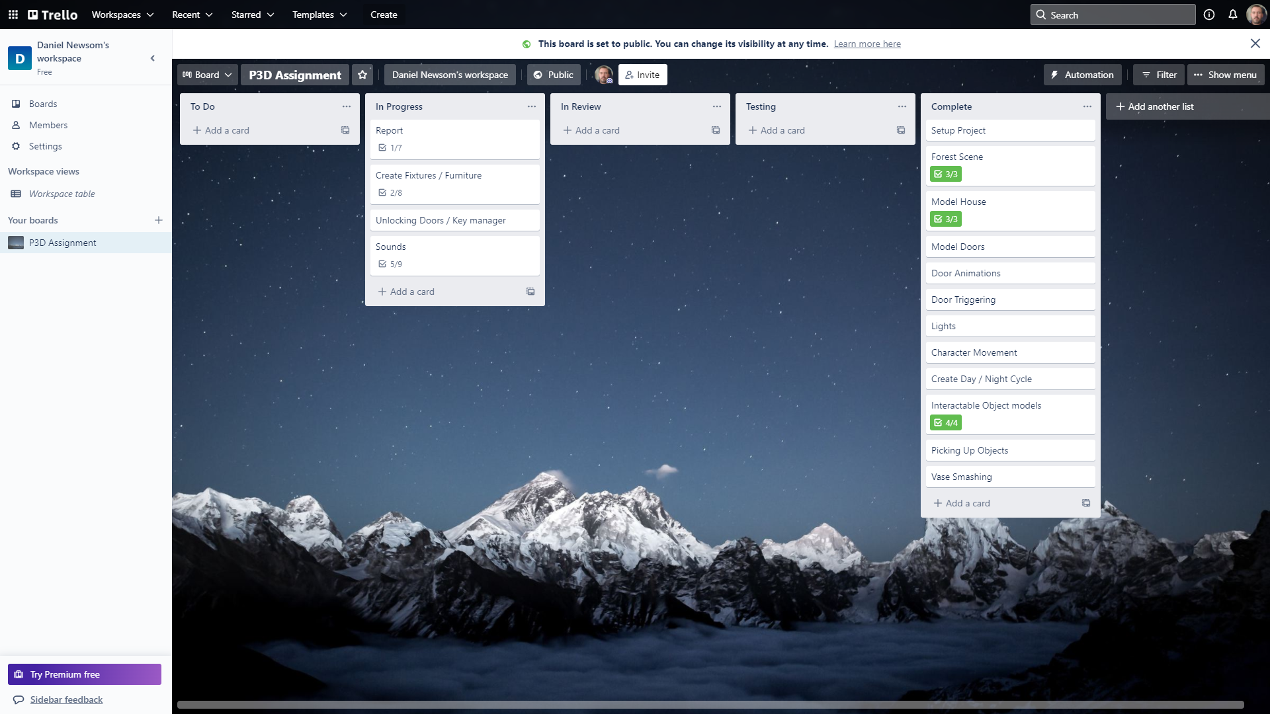

Figure 2.15 - Trello (Atlassian, 2021) board status at the end of week 4

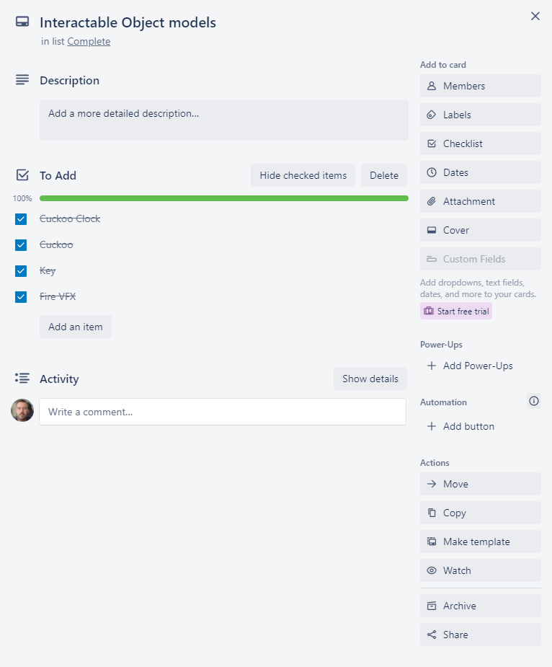

Figure 2.16 – Expanded Interactable object models card.

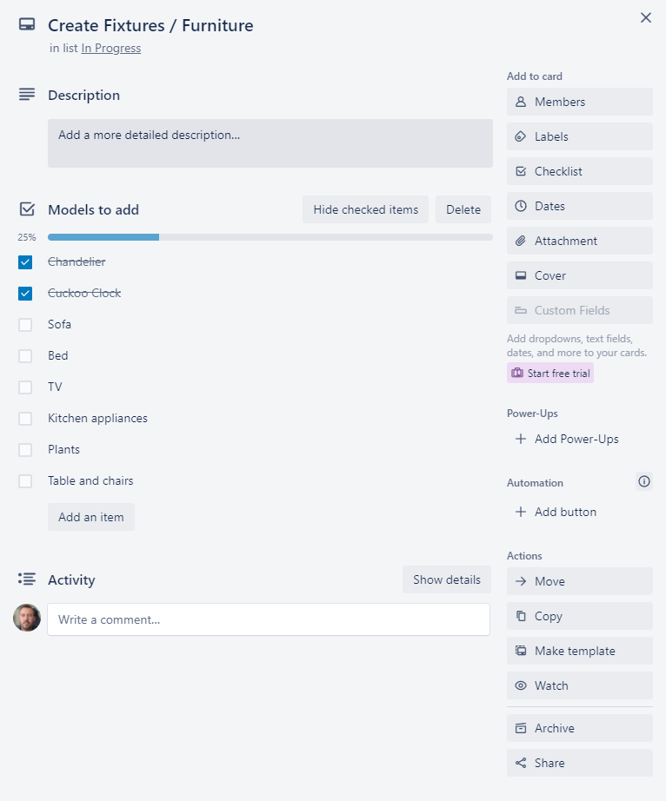

Figure 2.17 – Expanded Create Fixtures / Furniture card.

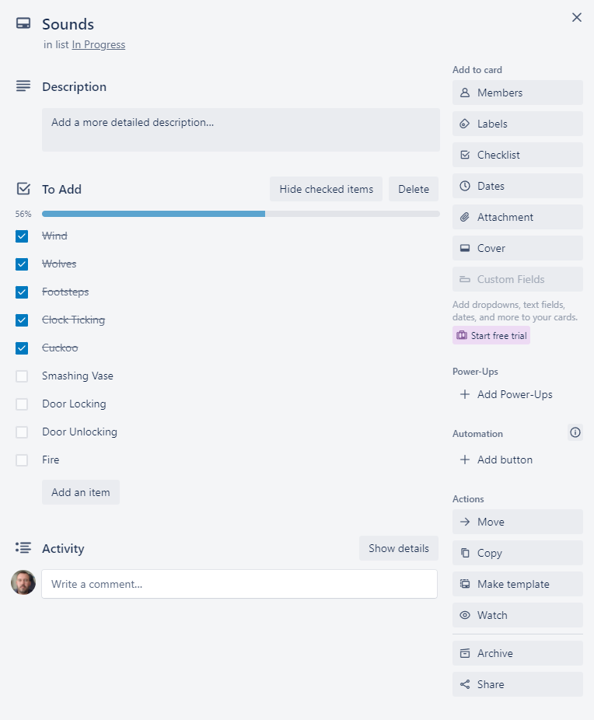

Figure 2.18 – Expanded Sounds card.

## Week 5

The plan for week 5 is as follows

* Implement collecting and using keys
* Add remaining fixtures and fittings
* Add remaining sounds
* Record first demo video for feedback

The updated Trello (Atlassian, 2021) board at the end of week 5 is shown below (Figure 2.19) as well as the relevant expanded Create fixtures / furniture card (figures 2.20) and Sounds card (figure 2.21).

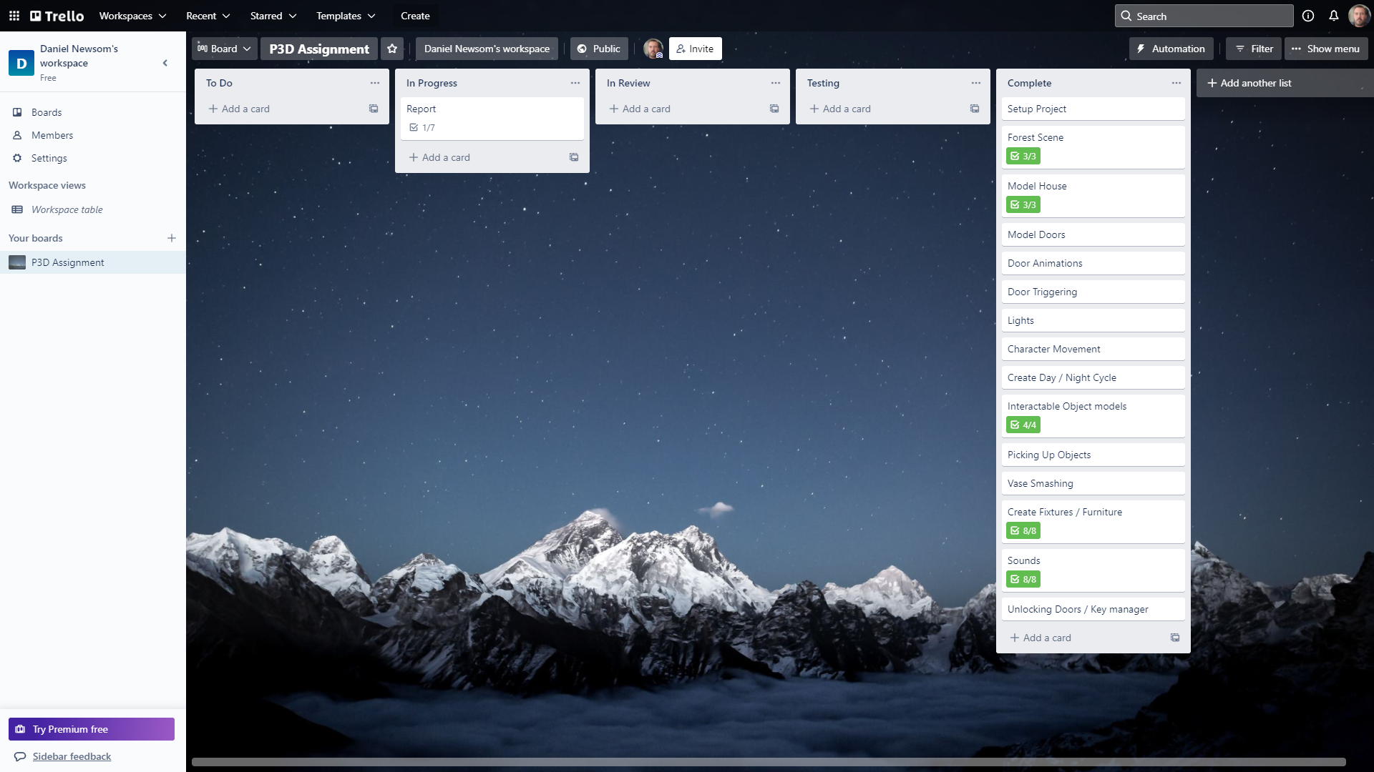

Figure 2.19 - Trello (Atlassian, 2021) board status at the end of week 5

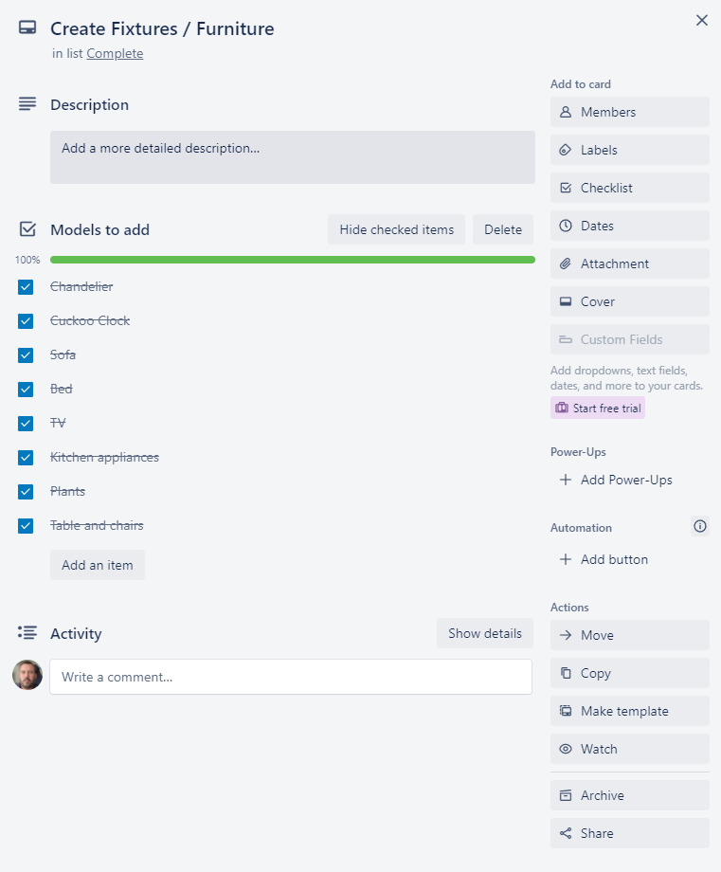

Figure 2.20 – Expanded Create Fixtures / Furniture card.

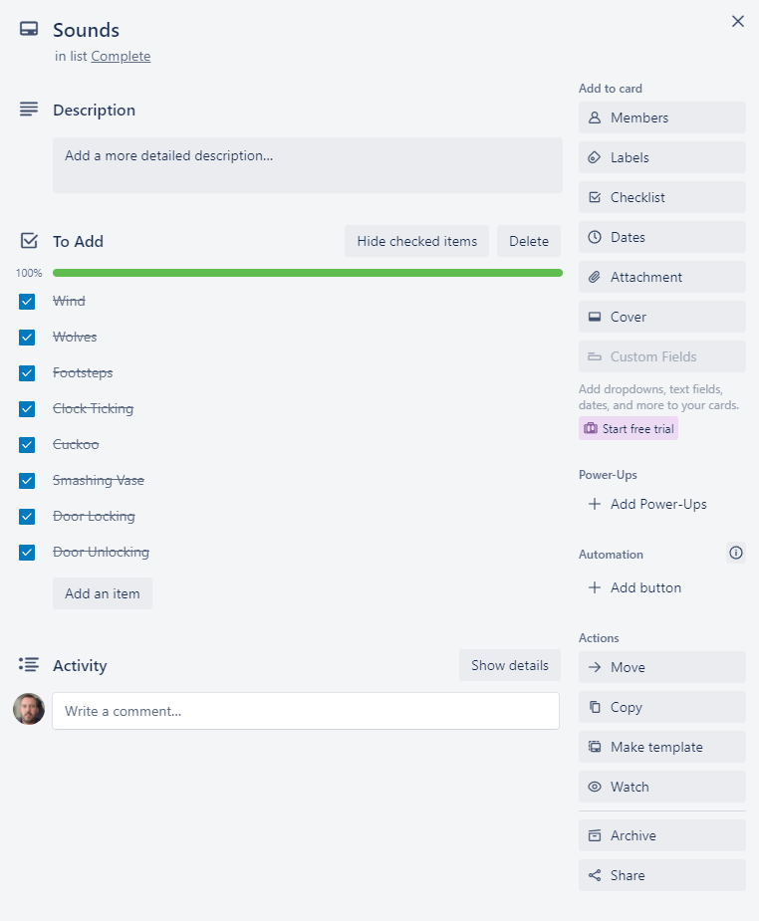

Figure 2.18 – Expanded Sounds card.

## Week 6

The plan for week 6 is as follows

* Add Asset references to the report
* Refactor and tidy up all scripts
* Start technical element section

The updated Trello (Atlassian, 2021) board at the end of week 5 is shown below (Figure 2.19) as well as the relevant expanded Create fixtures / furniture card (figures 2.20) and Sounds card (figure 2.21).

# Technical Element - Vectors

## Introduction

A vector is described by Marc Beaujean (Beaujean, 2020) as “a mathematical unit that can consist of more than one value.” He also states that “Its important to distinguish between vectors in traditional mathematics and in game engines”.

A vector in the context of game development is used to store an objects various elements current state. They consist mainly of Vector3 with x,y and z values used for objects in 3D space or Vector2 with just the x and y value for objects in 2D space.

## Uses in Video Games

### Main uses

The main uses of Vectors are as follows.

* Store an objects position, this is either relative to the scene as a whole (Global) or the objects parent as an offset (local).
* Store an objects rotation around each of the vectors axes.
* Store an objects current velocity and direction.

I used this in my project when detecting the vases collision with another object. If the objects current velocity in either the x,y or z axis was above the given threshold, then the SmashVase() method was called to detroy the object.

### Movement

Using vectors we can move an object by adding a movement vector to the objects current position to calculate the objects new position, as shown below (figure 3.1) in the diagram from R Nave (Nave, 2021)

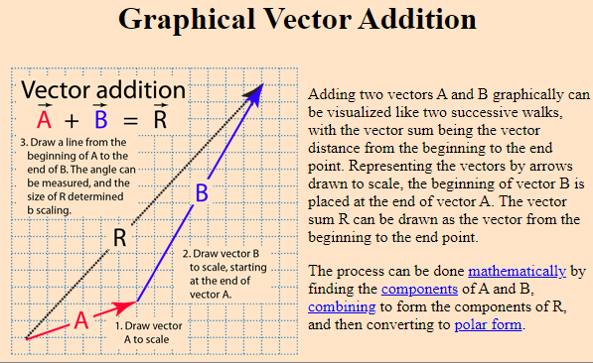

Figure 3.1 – Vector addition diagram (Nave, 2021)

We can move towards another object by getting the direction between them, by subtracting the target objects position from the current objects movement and normalizing this value to remove the distance. We can then add this value, multiplied by a distance value to the current objects position vector in order to move towards that object by the given distance.

This is demonstrated in the code snippet below from Saad Khan (Khan, 2017)

// Calculate direction vector

Vector3 dir = obj1.transform.position - ob2.transform.position;  
// Normalize resultant vector to unit Vector  
dir = dir.normalized;  
// Move in the direction of the direction vector every frame   
obj1.transform.position += dir * Time.deltaTime * speed;

This process can be simplified by using the built in MoveToward() function from the Vector classes.

### Distance

Vectors can be used to calculate distances between tho objects using the Distance(Vector3,Vector3) method from the Vector Classes which returns the Euclidean distance between the two vectors.

The formula used for this calculation is as described by rayman may (may, 2014)

Given two points in space $point a= \left(x_{0},y_{0},z_{0}\right), point b(x_{1},y_{1},z_{1})$

$distance=\sqrt{{(x_{1}-x_{0})}^{2}+{(y_{1}-y_{0})}^{2}+{(z_{1}-z_{0})}^{2}}$

### Other Uses

Vectors within Unity can also be used to store various other variables requiring multiple values for example a range between two floats by storing the min and max values in the x and y values respectively.

I used a Vector2 in my Lightbulb script to set a min and max wait time for the bulb to wait before flickerin off and on again.

[SerializeField] private Vector2 flickerDelay = new Vector2(0.1f, 5f);

I then selected a random value between these to use as the countdown until the next flicker

private void **FixedUpdate**()  
{  
 if (flickering)  
 {  
 _flickerDelayTimer -= Time.deltaTime;  
 if (_flickerDelayTimer <= 0)  
 {  
 SwitchLightsOff();  
 _flickerDelayTimer = Random.Range(flickerDelay.x, flickerDelay.y);  
 Invoke(nameof(SwitchLightsOn),Random.Range(flickerOffTime.x,flickerOffTime.y));  
 }  
 }  
}

# Script

# Unique Element

# Summary

# Future Work

# References

## Github

Main Github page - <https://github.com/dgnewsom>

Project Repository - <https://github.com/dgnewsom/215851_P3D>

## Assets

### Models

* **Apple Model** - (Baria3DAsset(Apple), 2020)
* **Banana Model** - (Baria3DAsset(Banana), 2020)
* **Bath** - (diger-mpt, 2019)
* **Bath Tap** - (Renderscope, 2015)
* **Bookcases** - (Newsom (Clue), 2021)
* **Desk** - (Newsom (Clue), 2021)
* **Dining Set**
  + **Table** - (Newsom (Clue), 2021)
  + **Chair** - (Newsom (Chair), 2021)
* **Fridge** - (Newsom (Clue), 2021)
* **Hat Stand**
  + **Gangster Hat** - (MichalCavrnoch, 2020)
  + **Cowboy Hat** - (vanmourik-elise, 2016)
* **Kitchen Cupboards** - (Newsom (Clue), 2021)
* **Orange Model** - (mikailtasim, 2019)
* **Oven** - (Newsom (Clue), 2021)
* **Piano** - (choughry, 2021)
* **Plant** - (dominiklesniak, 2018)
* **Pool Table** - (Newsom (Pool Table), 2021)
* **Shower** - (claudiodubas, 2015)
* **Shower Cubicle** - (sweethome3d, 2013)
* **Sink** - (BSW2142, 2018)
* **Sofa** - (Newsom (Sofa), 2021)
* **Telephone Table** 
  + **Table** - (Newsom (Clue), 2021)
  + **Old Phone** - (Polymake, 2020)
  + **NoteBook** - (Hard, 2021)
* **Television and Stand** - (Newsom (Clue), 2021)
* **Toilet Model** - (MarkStead, 2021)
* **Toilet Roll Models** - (dandcowan, 2021)

### Audio

* **Bird Song** - (Imjeax, 2018)
* **Clock Tick** - (straget, 2019)
* **Cuckoo** - (InspectorJ, 2017)
* **Door Close** - (rivernile7, 2014)
* **Door Lock / Unlock** - (Fabrizio84, 2019)
* **Door Open** - (pagancow, 2006)
* **Footstep Sounds** - (Glowkeeper_(Footsteps_Audio), 2021)
* **Piano** - (deadrobotmusic, 2021)
* **Serving Hatch** - (craigsmith, 2018)
* **Vase Smash** - (kingsrow, 2013)
* **Wind** - (nsstudios, 2019)
* **Wolf Sounds** 
  1. (y89312, 2011)
  2. (killyourpepe, 2017)
  3. (cazadordoblekatana, 2018)
  4. (newagesoup, 2016)
  5. (NaturesTemper, 2017)

### Fonts

* **Title Font** - (PutraCetol, 2021)
* **UI Font** - (Art_Power, 2017)

### Sprites

* **Smoke Sprite Sheet** - (Beast, 2013)

### Scripts

* **Character Controller** - (Unity_Starter_Assets, 2021)
* **Footsteps code** - (Glowkeeper_(Footsteps_Code), 2021)

### Full References

Art_Power, 2017. *DaFont - Stranger back in the Night.* [Online]   
Available at: https://www.dafont.com/stranger-back-in-the-night.font  
[Accessed 9 December 2021].

Atlassian, 2021. *Trello.* [Online]   
Available at: https://trello.com/  
[Accessed 5 November 2021].

Baria3DAsset(Apple), 2020. *CGTrader - Apple Fruit Free low-poly 3D model.* [Online]   
Available at: https://www.cgtrader.com/free-3d-models/food/fruit/apple-fruit-afa5e664-8ff8-4598-9568-a21c35520ca3  
[Accessed 7 December 2021].

Baria3DAsset(Banana), 2020. *CGTrader - Banana Free low-poly 3D model.* [Online]   
Available at: https://www.cgtrader.com/free-3d-models/food/fruit/banana-a86fda85-aa6c-4261-8d87-da597aa55f28  
[Accessed 7 December 2021].

Beast, 2013. *OpenGameArt.Org - Swirling Prerendered Smoke Animation with seamless looping..* [Online]   
Available at: https://opengameart.org/content/smoke-aura  
[Accessed 3 December 2021].

Beaujean, M., 2020. *Vector Maths for Game Dev Beginners.* [Online]   
Available at: https://www.gamedeveloper.com/disciplines/vector-maths-for-game-dev-beginners  
[Accessed 10 December 2021].

Blender, 2021. *Blender.* [Online]   
Available at: https://www.blender.org/  
[Accessed 5 November 2021].

BSW2142, 2018. *CGTrader - Marble Bathroom Sink Free low-poly 3D model.* [Online]   
Available at: https://www.cgtrader.com/free-3d-models/furniture/other/bathroom-sink-07b46f36-c6ba-41d5-ad60-9475c96988fc  
[Accessed 8 December 2021].

cazadordoblekatana, 2018. *Freesound - 15-WolfCrying.wav.* [Online]   
Available at: https://freesound.org/people/cazadordoblekatana/sounds/429109/  
[Accessed 29 November 2021].

choughry, 2021. *CGTrader - Piano Free 3D model.* [Online]   
Available at: https://www.cgtrader.com/free-3d-models/interior/house/piano-7956bf16-98c3-4bd3-8171-8df382638c08  
[Accessed March 2021].

claudiodubas, 2015. *CGTrader - Shower 4 Free 3D model.* [Online]   
Available at: https://www.cgtrader.com/free-3d-models/interior/bathroom/shower-4--2  
[Accessed 8 December 2021].

craigsmith, 2018. *Freesound - G31-04-Small Wooden Door.wav.* [Online]   
Available at: https://freesound.org/people/craigsmith/sounds/438442/  
[Accessed 9 December 2021].

dandcowan, 2021. *CGTrader - Toilet Rolls Free 3D model.* [Online]   
Available at: https://www.cgtrader.com/free-3d-models/household/other/toilet-rolls  
[Accessed 8 December 2021].

deadrobotmusic, 2021. *Freesound - SOS Dark Piano Loop [148bpm] [C Minor].* [Online]   
Available at: https://freesound.org/people/deadrobotmusic/sounds/574346/  
[Accessed 8 December 2021].

diger-mpt, 2019. *CGTrader - Asymmetric bathtub size 1600x1100 Free 3D model.* [Online]   
Available at: https://www.cgtrader.com/free-3d-models/interior/bathroom/asymmetric-bathtub-size-1600x1100  
[Accessed 8 December 2021].

dominiklesniak, 2018. *CGTrader - monstera-deliciosa.* [Online]   
Available at: https://www.cgtrader.com/free-3d-models/plant/pot-plant/monstera-deliciosa  
[Accessed March 2021].

Fabrizio84, 2019. *Freesound - Locking Door.* [Online]   
Available at: https://freesound.org/people/Fabrizio84/sounds/458013/  
[Accessed 6 December 2021].

Glowkeeper_(Footsteps_Audio), 2021. *Github - P3D/assets/audio/.* [Online]   
Available at: https://github.com/glowkeeper/P3D/tree/master/assets/audio  
[Accessed 29 November 2021].

Glowkeeper_(Footsteps_Code), 2021. *Github - P3D Lab for Week 4, Session 2 - Audio in Unity.* [Online]   
Available at: https://github.com/glowkeeper/P3D/blob/master/docs/labs/week4Session2.md  
[Accessed 29 November 2021].

Hard, A., 2021. *CGTrader - A4 Notebook 3d model nots student mockup school Free low-poly 3D model.* [Online]   
Available at: https://www.cgtrader.com/free-3d-models/household/other/a4-notebook-3d-model-nots-student-mockup-school  
[Accessed March 2021].

Imjeax, 2018. *Freesound - Forest Ambient LOOP.* [Online]   
Available at: https://freesound.org/people/Imjeax/sounds/427400/  
[Accessed 29 November 2021].

InspectorJ, 2017. *Freesound - Cuckoo Clock, Single, A.wav.* [Online]   
Available at: https://freesound.org/people/InspectorJ/sounds/398194/  
[Accessed 29 November 2021].

Khan, S., 2017. *Unity - moving one gameobject towards another.* [Online]   
Available at: https://answers.unity.com/questions/1303472/moving-one-gameobject-towards-another.html  
[Accessed 10 December 2021].

killyourpepe, 2017. *Freesound - DuskWolf.wav.* [Online]   
Available at: 1. https://freesound.org/people/killyourpepe/sounds/395192/  
[Accessed 29 November 2021].

kingsrow, 2013. *Freesound - BreakingVase02.wav.* [Online]   
Available at: https://freesound.org/people/kingsrow/sounds/194684/  
[Accessed 9 December 2021].

MarkStead, 2021. *CGTrader - Toilet Suite Kohler Reach 5233A-0 Free 3D model.* [Online]   
Available at: https://www.cgtrader.com/free-3d-models/interior/bathroom/toilet-suite-kohler-reach-5233a-0  
[Accessed 8 December 2021].

may, r., 2014. *Calculate distance in 3D space.* [Online]   
Available at: https://math.stackexchange.com/q/1069627  
[Accessed 10 December 10].

MichalCavrnoch, 2020. *CGTrader - Gangster hats Free 3D model.* [Online]   
Available at: https://www.cgtrader.com/free-3d-models/character/clothing/gangster-hats  
[Accessed March 2021].

mikailtasim, 2019. *CGTrader - Orange Free 3D model.* [Online]   
Available at: https://www.cgtrader.com/free-3d-models/food/fruit/orange-f548261d-6a73-4f1f-a318-0236d1c2b22b  
[Accessed 7 December 2021].

NatureManufacture_Forest_Environment, 2021. *Forest Environment - Dynamic Nature.* [Online]   
Available at: https://assetstore.unity.com/packages/3d/vegetation/forest-environment-dynamic-nature-150668  
[Accessed 5 November 2021].

NatureManufacture_Mountain_Trees, 2021. *Mountain Trees - Dynamic Nature.* [Online]   
Available at: https://assetstore.unity.com/packages/3d/vegetation/trees/mountain-trees-dynamic-nature-107004  
[Accessed 5 November 2021].

NaturesTemper, 2017. *Freesound - Wolf howl.* [Online]   
Available at: https://freesound.org/people/NaturesTemper/sounds/398430/  
[Accessed 29 November 2021].

Nave, R., 2021. *Basic Vector Operations.* [Online]   
Available at: http://hyperphysics.phy-astr.gsu.edu/hbase/vect.html  
[Accessed 10 December 2021].

newagesoup, 2016. *Freesound - wolf-growl.wav.* [Online]   
Available at: https://freesound.org/people/newagesoup/sounds/338674/  
[Accessed 29 November 2021].

Newsom (Chair), D., 2021. *Daniel Newsom - Photorealistic Chair.* [Online]   
Available at: https://danielnewsom.co.uk/modelling/chair.php  
[Accessed 7 December 2021].

Newsom (Clue), D., 2021. *Daniel Newsom - Clue.* [Online]   
Available at: https://danielnewsom.co.uk/gamepages/clue.php  
[Accessed 7 December 2021].

Newsom (Pool Table), D., 2021. *Daniel Newsom - Pool Table.* [Online]   
[Accessed 7 December 2021].

Newsom (Sofa), D., 2021. *Daniel Newsom - Sofa.* [Online]   
[Accessed 7 December 2021].

nsstudios, 2019. *FreeSound - wind blowing loop 1.* [Online]   
Available at: https://freesound.org/people/nsstudios/sounds/479192/  
[Accessed 29 November 2021].

pagancow, 2006. *Freesound - dorm door opening.wav.* [Online]   
Available at: https://freesound.org/people/pagancow/sounds/15419/  
[Accessed 6 December 2021].

Polymake, 2020. *CGTrader - Old Phone Low-poly 3D model.* [Online]   
Available at: https://www.cgtrader.com/free-3d-models/electronics/phone/old-phone-7bab903e-bdab-45b3-9a29-7077ea99f37c  
[Accessed March 2021].

PutraCetol, S., 2021. *DaFont - The Night Lamp.* [Online]   
Available at: https://www.dafont.com/the-night-lamp.font  
[Accessed 9 December 2021].

Renderscope, 2015. *CGTrader - Bathroom faucet Free 3D model.* [Online]   
Available at: https://www.cgtrader.com/free-3d-models/interior/bathroom/bathroom-faucet-2--2  
[Accessed 8 December 2021].

rivernile7, 2014. *Freesound - Door Open And Close.* [Online]   
Available at: https://freesound.org/people/rivernile7/sounds/234244/  
[Accessed 6 December 2021].

straget, 2019. *Freesound - Antique wall clock.wav.* [Online]   
Available at: https://freesound.org/people/straget/sounds/456236/  
[Accessed 29 November 2021].

sweethome3d, 2013. *CGtrader - Shower cabin Free 3D model.* [Online]   
Available at: https://www.cgtrader.com/free-3d-models/household/other/shower-cabin  
[Accessed 8 December 2021].

Unity_Starter_Assets, 2021. *Starter Assets - First Person Character Controller.* [Online]   
Available at: https://assetstore.unity.com/packages/essentials/starter-assets-first-person-character-controller-196525  
[Accessed 5 November 2021].

Unity, 2021. *Unity.* [Online]   
Available at: https://unity.com/  
[Accessed 25 November 2021].

vanmourik-elise, 2016. *CGTrader - Cowboy Hat Free 3D model.* [Online]   
Available at: https://www.cgtrader.com/free-3d-models/character/clothing/cowboy-hat-d21039a1-a146-4e56-8d8f-060629853f81  
[Accessed March 2021].

y89312, 2011. *Freesound - 41.wav.* [Online]   
Available at: https://freesound.org/people/y89312/sounds/139924/  
[Accessed 29 November 2021].

# Appendix

## Scripts

### Candle.cs

using UnityEngine;  
  
public class **Candle** : MonoBehaviour  
{  
 [SerializeField] private GameObject **keyObjectToAppear**;  
   
 private readonly Vector3 _targetScale = new Vector3(0.75f,0.75f,0.1f);  
 private bool _burningDown;  
  
 private void **Update**()  
 {  
 if (_burningDown)  
 {  
 transform.localScale = Vector3.Lerp(transform.localScale, _targetScale, Time.deltaTime);  
 if (transform.localScale.z <= 0.15f)  
 {  
 keyObjectToAppear.SetActive(true);  
 _burningDown = false;  
 }  
 }  
 }  
  
 public void StartBurning()  
 {  
 _burningDown = true;  
 }  
}

### CuckooClock.cs

using UnityEngine;  
  
public class **CuckooClock** : MonoBehaviour  
{  
 [SerializeField] private AudioClip **cuckooSound**;  
 [SerializeField] private GameObject **cuckooToDrop**;  
   
 private AudioSource _cuckooClockAudioSource;  
 private bool _hasPlayed;  
 private static readonly int Cuckoo = Animator.StringToHash("Cuckoo");  
  
 private void **Start**()  
 {  
 _cuckooClockAudioSource = transform.parent.GetComponent<AudioSource>();  
 cuckooToDrop.SetActive(false);  
 }  
   
 private void **OnTriggerEnter**(Collider other)  
 {  
 if(_hasPlayed){return;}  
   
 if (other.CompareTag("Player"))  
 {  
 GetComponent<Animator>().SetBool(Cuckoo,true);  
 _hasPlayed = true;  
 }  
 }  
  
 public void PlayCuckooSound()  
 {  
 _cuckooClockAudioSource.PlayOneShot(cuckooSound);  
 }  
  
 public void DropCuckoo()  
 {  
 cuckooToDrop.SetActive(true);  
 }  
}

### DayNightController.cs

using UnityEngine;  
using UnityEngine.Events;  
using UnityEngine.Rendering;  
  
public class **DayNightController** : MonoBehaviour  
{  
 [Header("Volume Profiles")]  
 [SerializeField] private VolumeProfile **dayProfile**;  
 [SerializeField] private VolumeProfile **nightProfile**;  
 [Header("Audio")]  
 [SerializeField] private AudioClip **nightAmbientSound**;  
 [SerializeField] private AudioClip **dayAmbientSound**;  
 [Header("Event to trigger on switch to daytime")]  
 [SerializeField] private UnityEvent **endingEvent**;  
  
 private LightBulb[] _lights;  
 private bool _isDaytime;  
 private AudioSource _outsideAudioSource;  
 private Volume _volume;  
 private Animator _animator;  
 private float _animationSpeed;  
 private static readonly int Speed = Animator.StringToHash("Speed");  
 private static readonly int Daytime = Animator.StringToHash("IsDaytime");  
  
 public bool IsDaytime => _isDaytime;  
  
 private void **Start**()  
 {  
 _animator = GetComponent<Animator>();  
 _volume = GetComponentInChildren<Volume>();  
 _lights = FindObjectsOfType<LightBulb>();  
 _animationSpeed = _animator.GetFloat(Speed);  
 _outsideAudioSource = GetComponent<AudioSource>();  
 SetNighttime();  
 }  
  
 private void UpdateAnimator()  
 {  
 _animator.SetBool(Daytime,_isDaytime);  
 }  
  
 private void SetDaytime()  
 {  
 _isDaytime = true;  
 _outsideAudioSource.clip = dayAmbientSound;  
 _outsideAudioSource.Play();  
 _volume.profile = dayProfile;  
 UpdateAnimator();  
 Invoke(nameof(EndingEvent),1f);  
 }  
  
 private void SetNighttime()  
 {  
 _isDaytime = false;  
 _outsideAudioSource.clip = nightAmbientSound;  
 _outsideAudioSource.Play();  
 _volume.profile = nightProfile;  
 UpdateAnimator();  
 }  
  
 [ContextMenu("Toggle Day/Night")]  
 public void ToggleDayNight()  
 {  
 _isDaytime = !_isDaytime;  
 if (_isDaytime)  
 {  
 SetDaytime();  
 }  
 else  
 {  
 SetNighttime();  
 }  
 }  
  
 [ContextMenu("Skip To Day")]  
 public void SkipToDaytime()  
 {  
 SetDaytime();  
 _animator.SetFloat(Speed,5f);  
 }  
  
 [ContextMenu("Skip To Night")]  
 public void SkipToNighttime()  
 {  
 SetNighttime();  
 _animator.SetFloat(Speed,5f);  
 }  
  
 public void EnableHouseLights()  
 {  
 foreach (LightBulb lightBulb in _lights)  
 {  
 lightBulb.enabled = true;  
 }  
 }  
   
 public void DisableHouseLights()  
 {  
 foreach (LightBulb lightBulb in _lights)  
 {  
 lightBulb.enabled = false;  
 }  
   
 }  
  
 public void ResetSpeed()  
 {  
 _animator.SetFloat(Speed,_animationSpeed);  
 }  
  
 private void EndingEvent()  
 {  
 endingEvent.Invoke();  
 }  
}

### Door.cs

using System.Collections;  
using UnityEngine;  
  
//Door states (indexes match animator int values)  
public enum DoorState  
{  
 OpenIn,  
 Closed,  
 OpenOut  
}  
public class **Door** : MonoBehaviour  
{  
 [Header("Lock settings")]  
 [SerializeField] private bool **isLocked**;  
 [Header("Trigger daytime / ending")]  
 [SerializeField] private bool **triggerDaytime**;  
 [Header("KeyType required to unlock")]  
 [SerializeField] private KeyType **keyType**;  
  
 private DoorState _currentState = DoorState.Closed;  
 private Animator _animator;  
 private readonly float coolDownDelay = 0.5f;  
 private float _cooldownTimer;  
 private KeyManager _keyManager;  
 private DoorTexts _doorTexts;  
 private DoorSounds _doorSounds;  
 private static readonly int OpenState = Animator.StringToHash("OpenState");  
  
 public DoorState CurrentState => _currentState;  
  
 public bool IsLocked => isLocked;  
  
 public KeyType Type => keyType;  
  
 private void **Start**()  
 {  
 _animator = GetComponentInChildren<Animator>();  
 _keyManager = FindObjectOfType<KeyManager>();  
 _doorTexts = GetComponentInChildren<DoorTexts>();  
 _doorSounds = GetComponentInChildren<DoorSounds>();  
 }  
  
 private void **FixedUpdate**()  
 {  
 if (_cooldownTimer == 0f){return;}  
   
 _cooldownTimer -= Time.deltaTime;  
  
 if (_cooldownTimer <= 0f)  
 {  
 _cooldownTimer = 0f;  
 SetDoorState(_currentState);  
 }  
 }  
  
 internal void SetDoorState(DoorState newState, float autoCloseDelay = 0f)  
 {  
 if(_cooldownTimer > 0){return;}  
  
 if (isLocked)  
 {  
 if (_keyManager.CheckIfKeyHeld(keyType) && newState != DoorState.Closed)  
 {  
 isLocked = false;  
 _doorSounds.PlayDoorUnlockSound();  
 _doorTexts.SetDoorText();  
 }  
 }  
 if (!isLocked && _currentState != newState)  
 {  
 _doorTexts.ClearDoorText();  
 _cooldownTimer = coolDownDelay;  
 StartCoroutine(DoorStateDelay(autoCloseDelay,newState));  
 if (triggerDaytime)  
 {  
 DayNightController dayNightController = FindObjectOfType<DayNightController>();  
 if (!dayNightController.IsDaytime)  
 {  
 dayNightController.SkipToDaytime();  
 }  
 }  
 }  
 }  
  
 private IEnumerator DoorStateDelay(float delay, DoorState newState)  
 {  
 yield return new WaitForSeconds(delay);  
 _currentState = newState;  
 _animator.SetInteger(OpenState,(int)_currentState);  
 }  
  
 public void LockDoor()  
 {  
 if (isLocked) return;  
 isLocked = true;  
 StartCoroutine(DoorStateDelay(0,DoorState.Closed));  
 }  
}

### DoorLockTrigger.cs

using UnityEngine;  
  
public class **DoorLockTrigger** : MonoBehaviour  
{  
 private Door _door;  
  
 private void **Start**()  
 {  
 _door = transform.parent.GetComponent<Door>();  
 }  
   
 private void **OnTriggerEnter**(Collider other)  
 {  
 if (other.CompareTag("Player"))  
 {  
 _door.LockDoor();  
 }  
 }  
}

### DoorSounds.cs

using UnityEngine;  
  
public class **DoorSounds** : MonoBehaviour  
{  
 [SerializeField] private AudioClip **doorCloseSound**;  
 [SerializeField] private AudioClip **doorOpenSound**;  
 [SerializeField] private AudioClip **doorLockSound**;  
 [SerializeField] private AudioClip **doorUnlockSound**;  
  
 private Door _door;  
 private AudioSource _audioSource;  
   
 void **Start**()  
 {  
 _audioSource = GetComponent<AudioSource>();  
 _door = transform.parent.GetComponent<Door>();  
 }  
  
 public void PlayDoorCloseSound()  
 {  
 _audioSource.PlayOneShot(doorCloseSound);  
 if (_door.IsLocked)  
 {  
 Invoke(nameof(PlayDoorLockSound),0.25f);  
 }  
 }   
   
 public void PlayDoorOpenSound()  
 {  
 _audioSource.PlayOneShot(doorOpenSound);  
 }   
   
 public void PlayDoorLockSound()  
 {  
 _audioSource.PlayOneShot(doorLockSound);  
 }   
   
 public void PlayDoorUnlockSound()  
 {  
 _audioSource.PlayOneShot(doorUnlockSound);  
 }  
}

### DoorTexts.cs

using TMPro;  
using UnityEngine;  
  
public class **DoorTexts** : MonoBehaviour  
{  
 [SerializeField] private GameObject[] **textPanels**;  
   
 private Door _door;  
 private KeyManager _keyManager;  
 private Transform _player;  
 private Animator _animator;  
 private static readonly int OpenState = Animator.StringToHash("OpenState");  
  
 private void **Start**()  
 {  
 _door = GetComponentInParent<Door>();  
 _keyManager = FindObjectOfType<KeyManager>();  
 _player = GameObject.FindWithTag("Player").transform;  
 _animator = transform.parent.GetComponentInChildren<Animator>();  
 ClearDoorText();  
 }  
  
 private void **OnTriggerStay**(Collider other)  
 {  
 if (other.CompareTag("Player"))  
 {  
 SetDoorText();  
 }  
 }  
  
 private void **OnTriggerExit**(Collider other)  
 {  
 Invoke(nameof(ClearDoorText),1f);  
 }  
   
 public void SetDoorText()  
 {  
 ClearDoorText();  
 GameObject nearestTextPanel = GetNearestTextPanel();  
 if(nearestTextPanel == null){return;}  
 nearestTextPanel.SetActive(true);  
 if (_door.IsLocked)  
 {  
 if (_keyManager.CheckIfKeyHeld(_door.Type))  
 {  
 UpdateDoorText(nearestTextPanel.GetComponentInChildren<TMP_Text>(),$"Unlock");  
 }  
 else  
 {

UpdateDoorText(nearestTextPanel.GetComponentInChildren<TMP_Text>(),

$"{KeyManager.GetKeyName(_door.Type)}\nkey\nRequired");  
 }  
 }  
 else  
 {  
 if(_animator.GetInteger(OpenState) == 1)  
 {  
 UpdateDoorText(nearestTextPanel.GetComponentInChildren<TMP_Text>(),$"Open");  
 }  
 else  
 {  
 ClearDoorText();  
 }  
 }  
 }  
  
 private GameObject GetNearestTextPanel()  
 {  
 GameObject nearestTextPanel = null;  
 float distance = float.MaxValue;  
 foreach (GameObject textPanel in textPanels)  
 {  
 float doorTextDistance = Vector3.Distance(textPanel.transform.position, _player.position);  
 if (doorTextDistance < distance)  
 {  
 distance = doorTextDistance;  
 nearestTextPanel = textPanel;  
 }  
 }  
 return nearestTextPanel;  
 }  
  
 public void ClearDoorText()  
 {  
 foreach (GameObject textPanel in textPanels)  
 {  
 textPanel.SetActive(false);  
 }  
 }  
   
 private void UpdateDoorText(TMP_Text nearestDoorText, string newDoorText)  
 {  
 nearestDoorText.text = newDoorText;  
 }  
}

### DoorTrigger.cs

using UnityEngine;  
  
public class **DoorTrigger** : MonoBehaviour  
{  
 [SerializeField] private DoorState **doorState**;  
   
 private Door _door;  
 private PlayerInputHandler _inputHandler;  
  
 void **Start**()  
 {  
 _door = GetComponentInParent<Door>();  
 _inputHandler = FindObjectOfType<PlayerInputHandler>();  
 }  
  
 private void **OnTriggerStay**(Collider other)  
 {  
 if (other.CompareTag("Player"))  
 {  
 if (_inputHandler.Interact)  
 {  
 if (_door.CurrentState.Equals(DoorState.Closed))  
 {  
 _door.SetDoorState(doorState);  
 }  
 else if (_door.CurrentState.Equals(doorState))  
 {  
 _door.SetDoorState(DoorState.Closed);  
 }  
 else  
 {  
 _door.SetDoorState(DoorState.Closed);  
 }  
   
 }  
 }  
 }  
  
 private void **OnTriggerExit**(Collider other)  
 {  
 _door.SetDoorState(DoorState.Closed, 3f);  
 }  
}

### EndingTrigger.cs

using UnityEngine;  
using UnityEngine.Events;  
  
public class **EndingTrigger** : MonoBehaviour  
{  
 [SerializeField] private UnityEvent **endingEvent**;  
  
 private void **OnTriggerEnter**(Collider other)  
 {  
 if (other.CompareTag("Player"))  
 {  
 endingEvent.Invoke();  
 }  
 }  
}

### FireBasket.cs

using UnityEngine;  
using UnityEngine.Events;  
using UnityEngine.VFX;  
using Random = UnityEngine.Random;  
  
public class **FireBasket** : MonoBehaviour  
{  
 [SerializeField] private VisualEffect **fireEffect**;  
 [SerializeField] private PickupType **triggerObject**;  
 [SerializeField] private UnityEvent **triggerEvent**;  
  
 private Light _fireGlowLight;  
 private Vector2 _fireGlowIntensityRange = new Vector2(40,80);  
  
 private void **Start**()  
 {  
 _fireGlowLight = GetComponentInChildren<Light>();  
 }  
  
 private void **FixedUpdate**()  
 {  
 _fireGlowLight.intensity = Mathf.Lerp(_fireGlowLight.intensity,

Random.Range(_fireGlowIntensityRange.x,

_fireGlowIntensityRange.y),

Time.deltaTime * 10f);  
 }  
  
 private void **OnTriggerEnter**(Collider other)  
 {  
 if (!other.gameObject.TryGetComponent<Pickup>(out Pickup pickup)) return;  
 if (pickup.Type.Equals(triggerObject))  
 {  
 TriggerAction();  
 Destroy(other.gameObject);  
 }  
 }  
  
 private void TriggerAction()  
 {  
 _fireGlowIntensityRange *= 2;  
 fireEffect.SetFloat("SpawnRate",500f);  
 fireEffect.SetVector3("MinVelocity",new Vector3(0.5f,1.5f,0.25f));  
 fireEffect.SetVector3("MaxVelocity",new Vector3(0.5f,2f,0.25f));  
 fireEffect.SetFloat("BaseSize",0.75f);  
 Invoke(nameof(EnableItem),0.5f);  
 }  
  
 private void EnableItem()  
 {  
 triggerEvent.Invoke();  
 }  
}

### InsideHouseController.cs

using UnityEngine;  
  
public class **InsideHouseController** : MonoBehaviour  
{  
 [SerializeField] private AudioSource[] **outsideAudioSource**;  
 [SerializeField] private AudioSource[] **insideAudioSource**;  
  
 private bool _isInside = false;  
  
 public bool IsInside => _isInside;  
  
 private void **Start**()  
 {  
 SetInside(_isInside);  
 }  
  
 private void **OnTriggerStay**(Collider other)  
 {  
 if (other.CompareTag("Player"))  
 {  
 if (!_isInside)  
 {  
 _isInside = true;  
 SetInside(_isInside);  
 }  
 }  
 }  
  
 private void **OnTriggerExit**(Collider other)  
 {  
 if (other.CompareTag("Player"))  
 {  
 _isInside = false;  
 SetInside(_isInside);  
 }  
 }  
  
 public void SetInside(bool isInside)  
 {  
 if (isInside)  
 {  
 foreach (AudioSource audioSource in outsideAudioSource)  
 {  
 audioSource.volume = 0.2f;  
 }  
  
 foreach (AudioSource audioSource in insideAudioSource)  
 {  
 audioSource.volume = 1f;  
 }  
 }  
 else  
 {  
 foreach (AudioSource audioSource in outsideAudioSource)  
 {  
 audioSource.volume = 1f;  
 }  
  
 foreach (AudioSource audioSource in insideAudioSource)  
 {  
 audioSource.volume = 0f;  
 }  
 }  
 }  
}

### ItemGrabber.cs

using System.Collections.Generic;  
using UnityEngine;  
  
public class **ItemGrabber** : MonoBehaviour  
{  
 [SerializeField] private LayerMask **pickupLayerMask**;  
 [SerializeField] private float **raycastDistance** = 5f;  
 [SerializeField] private Transform **cameraTransform**;  
 [SerializeField] [Range(0f,20f)] private float **throwForce** = 10f;  
  
 private readonly List<GameObject> _heldItems = new List<GameObject>();  
 private KeyManager _keyManager;  
 private PlayerInputHandler _playerInputHandler;  
 private UIController _uiController;  
 private GameObject _currentItem;  
 private int _currentItemIndex;  
 private bool _inCooldown;  
  
 private void **Start**()  
 {  
 _playerInputHandler = FindObjectOfType<PlayerInputHandler>();  
 _keyManager = FindObjectOfType<KeyManager>();  
 _uiController = FindObjectOfType<UIController>();  
 }  
  
 private void **Update**()  
 {  
 if (Physics.Raycast(cameraTransform.position,

cameraTransform.forward,

out RaycastHit hitInfo,  
 raycastDistance,  
 pickupLayerMask,

QueryTriggerInteraction.Collide))  
 {  
 if (hitInfo.transform.TryGetComponent<Key>(out Key key))  
 {  
 _uiController.SetInfoDisplay($"Pick up {KeyManager.GetKeyName(key.DoorToOpen)} key");  
 }  
 else if (hitInfo.transform.TryGetComponent<Pickup>(out Pickup pickup))  
 {  
 _uiController.SetInfoDisplay($"Pick up {pickup.Type}");  
 }  
 }  
 else  
 {  
 _uiController.SetInfoDisplay("");  
 }  
  
 if(_inCooldown){return;}  
   
 if (_playerInputHandler.Throw)  
 {  
 if (hitInfo.transform)  
 {  
   
 if (hitInfo.transform.CompareTag("Key"))  
 {  
 if (hitInfo.transform.TryGetComponent<Key>(out Key key))  
 {  
 _keyManager.AddKey(key.DoorToOpen);  
 Destroy(hitInfo.transform.gameObject);  
 }  
 _inCooldown = true;  
 Invoke(nameof(ResetCooldown),0.2f);  
 return;  
 }  
  
 if (!hitInfo.transform.CompareTag("Pickup") ||

_heldItems.Contains(hitInfo.transform.gameObject)) return;  
 _currentItem = hitInfo.transform.gameObject;  
 _heldItems.Add(_currentItem);  
 _currentItemIndex = _heldItems.IndexOf(_currentItem);  
 SetActiveObject();  
 _currentItem.GetComponent<Rigidbody>().isKinematic = true;  
 _currentItem.GetComponent<Collider>().enabled = false;  
 Transform grabberTransform = transform;  
 _currentItem.transform.parent = grabberTransform;  
 _currentItem.transform.position = grabberTransform.position;  
 _currentItem.transform.rotation = grabberTransform.rotation;  
 _currentItem.transform.localScale = new Vector3(0.25f,0.25f,0.25f);  
 _inCooldown = true;  
 Invoke(nameof(ResetCooldown),0.2f);  
 }  
 else  
 {  
 if (!_currentItem) return;  
 GameObject itemToThrow = _currentItem;  
 _heldItems.Remove(itemToThrow);  
 if (_heldItems.Count > 0)  
 {  
 _currentItem = _heldItems[_heldItems.Count - 1];  
 _currentItemIndex = _heldItems.IndexOf(_currentItem);  
 SetActiveObject();  
 }  
 else  
 {  
 _currentItem = null;  
 }  
 itemToThrow.transform.parent = null;  
 itemToThrow.GetComponent<Collider>().enabled = true;  
 itemToThrow.TryGetComponent<Rigidbody>(out Rigidbody itemRb);  
 itemRb.isKinematic = false;  
 itemRb.AddForce(cameraTransform.forward * (throwForce * 100f), ForceMode.Acceleration);  
 itemToThrow.transform.localScale = new Vector3(1, 1, 1);  
 _inCooldown = true;  
 Invoke(nameof(ResetCooldown),0.2f);  
 }  
 }  
 else  
 {  
 if (_playerInputHandler.NextItem)  
 {  
 NextItem();  
 }  
 else if (_playerInputHandler.PreviousItem)  
 {  
 PreviousItem();  
 }  
 }  
 }  
  
 private void NextItem()  
 {  
 int numberOfItems = _heldItems.Count;  
 if(numberOfItems <= 1){return;}  
 if (_currentItemIndex == numberOfItems-1)  
 {  
 _currentItemIndex = 0;  
 }  
 else  
 {  
 _currentItemIndex++;  
 }  
 _currentItem = _heldItems[_currentItemIndex];  
 SetActiveObject();  
 _inCooldown = true;  
 Invoke(nameof(ResetCooldown),0.2f);  
 }  
  
 private void PreviousItem()  
 {  
 int numberOfItems = _heldItems.Count;  
 if(numberOfItems <= 1){return;}  
  
 if (_currentItemIndex == 0)  
 {  
 _currentItemIndex = numberOfItems - 1;  
 }  
 else  
 {  
 _currentItemIndex--;  
 }  
 _currentItem = _heldItems[_currentItemIndex];  
 SetActiveObject();  
 _inCooldown = true;  
 Invoke(nameof(ResetCooldown),0.2f);  
 }  
  
 private void SetActiveObject()  
 {  
 if (_heldItems.Count <= 0) return;  
  
 for (int i = 0; i < _heldItems.Count; i++)  
 {  
 if (i == _currentItemIndex)  
 {  
 _heldItems[i].SetActive(true);  
 }  
 else  
 {  
 _heldItems[i].SetActive(false);  
 }  
 }  
 }  
  
 private void ResetCooldown()  
 {  
 _inCooldown = false;  
 }  
}

### Key.cs

using UnityEngine;  
  
  
public class **Key** : MonoBehaviour  
{  
 [SerializeField] private KeyType **doorToOpen**;  
  
 public KeyType DoorToOpen => doorToOpen;  
}

### KeyDisplay.cs

using TMPro;  
using UnityEngine;  
using UnityEngine.UI;  
  
public class **KeyDisplay** : MonoBehaviour  
{  
 [SerializeField] private TMP_Text **keyDisplayText**;  
 [SerializeField] private Image **crossImage**;  
  
 private KeyType _keyType;  
  
 public KeyType Type => _keyType;  
  
 public void SetKeyType(KeyType keyType)  
 {  
 _keyType = keyType;  
 keyDisplayText.text = $"{KeyManager.GetKeyName(keyType)}";  
 }  
  
 public void SetCollected(bool collected)  
 {  
 crossImage.enabled = !collected;  
 }  
}

### KeyManager.cs

using System.Collections.Generic;  
using UnityEngine;  
  
public enum KeyType  
{  
 BackDoor,  
 Bathroom,  
 Bedroom,  
 Conservatory,  
 FrontDoor,  
 Kitchen,  
 Lounge  
}  
  
public class **KeyManager** : MonoBehaviour  
{  
 private List<KeyType> keysFound = new List<KeyType>();  
 private UIController _uiController;  
  
 private void **Start**()  
 {  
 _uiController = FindObjectOfType<UIController>();  
 }  
  
 public void AddKey(KeyType keyToAdd)  
 {  
 if (!keysFound.Contains(keyToAdd))  
 {  
 keysFound.Add(keyToAdd);  
 _uiController.UpdateKeys(keysFound);  
 }  
 }  
  
 public bool CheckIfKeyHeld(KeyType keyToCheck)  
 {  
 foreach (KeyType key in keysFound)  
 {  
 if (key.Equals(keyToCheck))  
 {  
 return true;  
 }  
 }  
 return false;  
 }  
  
 public static string GetKeyName(KeyType keyType)  
 {  
 switch (keyType)  
 {  
 case KeyType.BackDoor:  
 return "Back Door";  
 case KeyType.FrontDoor:  
 return "Front Door";  
 default:  
 return keyType.ToString();  
 }  
 }  
}

### LightBulb.cs

using UnityEngine;  
using Random = UnityEngine.Random;  
  
public class **LightBulb** : MonoBehaviour  
{  
 [SerializeField] private bool flickering;  
 [SerializeField] private Vector2 **flickerDelay** = new Vector2(0.1f, 5f);  
 [SerializeField] private Vector2 **flickerOffTime** = new Vector2(0.01f, 0.1f);  
  
 private float _flickerDelayTimer;  
 private Light[] _bulbs;  
  
 private void **Awake**()  
 {  
 _bulbs = GetComponentsInChildren<Light>();  
 }  
  
 private void **FixedUpdate**()  
 {  
 if (flickering)  
 {  
 _flickerDelayTimer -= Time.deltaTime;  
 if (_flickerDelayTimer <= 0)  
 {  
 SwitchLightsOff();  
 _flickerDelayTimer = Random.Range(flickerDelay.x, flickerDelay.y);  
 Invoke(nameof(SwitchLightsOn),Random.Range(flickerOffTime.x,flickerOffTime.y));  
 }  
 }  
 }  
  
 private void **OnEnable**()  
 {  
 SwitchLightsOn();  
 }  
  
 private void SwitchLightsOn()  
 {  
 foreach (Light bulb in _bulbs)  
 {  
 bulb.enabled = true;  
 }  
 }  
  
 private void **OnDisable**()  
 {  
 SwitchLightsOff();  
 }  
  
 private void SwitchLightsOff()  
 {  
 foreach (Light bulb in _bulbs)  
 {  
 bulb.enabled = false;  
 }  
 }  
}

### Pendulum.cs

using UnityEngine;  
  
public class **Pendulum** : MonoBehaviour  
{  
 [SerializeField] private AudioClip **tickSound**;  
 [SerializeField] private AudioClip **tockSound**;  
   
 private AudioSource _audioSource;  
 private bool _isTickNext;  
  
 private void **Start**()  
 {  
 _audioSource = GetComponent<AudioSource>();  
 }  
  
 private void **OnTriggerEnter**(Collider other)  
 {  
 if (other.CompareTag("Pendulum"))  
 {  
 if (_isTickNext)  
 {  
 _audioSource.PlayOneShot(tickSound);  
 }  
 else  
 {  
 _audioSource.PlayOneShot(tockSound);  
 }  
 _isTickNext = !_isTickNext;  
 }  
 }  
}

### PianoTrigger.cs

using UnityEngine;  
  
public class **PianoTrigger** : MonoBehaviour  
{  
 private AudioSource _audioSource;  
  
 private bool _isPlaying;  
 private void **Start**()  
 {  
 _audioSource = transform.parent.GetComponent<AudioSource>();  
 }  
  
 private void **OnTriggerEnter**(Collider other)  
 {  
 if(_isPlaying){return;}  
 if (other.CompareTag("Player"))  
 {  
 _audioSource.Play();  
 _isPlaying = true;  
 }  
 }  
}

### Pickup.cs

using UnityEngine;  
  
public enum PickupType  
{  
 Cuckoo,  
 Vase,  
 FruitBowl  
}  
  
public class **Pickup** : MonoBehaviour  
{  
 [SerializeField] private PickupType **pickupType**;  
  
 public PickupType Type => pickupType;  
  
 public static string GetPickupName(PickupType pickupType)  
 {  
 switch (pickupType)  
 {  
 case PickupType.FruitBowl:  
 return "Fruit Bowl";  
 default:  
 return pickupType.ToString();  
 }  
 }  
}

### PlayerInputHandler.cs

using UnityEngine;  
#if ENABLE_INPUT_SYSTEM && STARTER_ASSETS_PACKAGES_CHECKED  
using UnityEngine.InputSystem;  
#endif  
  
public class **PlayerInputHandler** : MonoBehaviour  
{  
 [Header("Movement Settings")]  
 [SerializeField] private bool **analogMovement**;  
  
 [Header("Mouse Cursor Settings")]  
 [SerializeField] private bool **lockCursor**;  
  
 private PlayerInput _input;  
  
 private Vector2 _move;  
 private Vector2 _look;  
 private bool _jump;  
 private bool _sprint;  
 private bool _interact;  
 private bool _throw;  
 private bool _nextItem;  
 private bool _previousItem;  
  
 public Vector2 Move => _move;  
 public Vector2 Look => _look;  
  
 public bool Jump  
 {  
 get => _jump;  
 set => _jump = value;  
 }  
  
 public bool Sprint => _sprint;  
  
 public bool Interact => _interact;  
  
 public bool Throw => _throw;  
  
 public bool AnalogMovement => analogMovement;  
  
 public bool NextItem => _nextItem;  
  
 public bool PreviousItem => _previousItem;  
  
 private void **Start**()  
 {  
 _input = GetComponent<PlayerInput>();  
 if (lockCursor)  
 {  
 Cursor.lockState = CursorLockMode.Locked;  
 }  
 }  
  
 public void OnControlsChanged()  
 {  
 print(_input.currentControlScheme);  
 }  
  
 public void OnMove(InputValue value)  
 {  
 _move = value.Get<Vector2>();  
 }  
  
 public void OnLook(InputValue value)  
 {  
 _look = value.Get<Vector2>();  
 }  
  
 public void OnJump(InputValue value)  
 {  
 _jump = value.isPressed;  
 }  
  
 public void OnSprint(InputValue value)  
 {  
 _sprint = value.isPressed;  
 }  
  
 public void OnInteract(InputValue value)  
 {  
 _interact = value.isPressed;  
 }  
  
 public void OnThrow(InputValue value)  
 {  
 _throw = value.isPressed;  
 }  
   
 public void OnNextItem(InputValue value)  
 {  
 _nextItem = value.isPressed;  
 }  
   
 public void OnPreviousItem(InputValue value)  
 {  
 _previousItem = value.isPressed;  
 }  
}

### ServingHatchTrigger.cs

using UnityEngine;  
  
public class **ServingHatchTrigger** : MonoBehaviour  
{  
 private Animator _animator;  
 private AudioSource _audioSource;  
 private bool _isPlaying;  
 private static readonly int IsActive = Animator.StringToHash("isActive");  
  
 // Start is called before the first frame update  
 void **Start**()  
 {  
 _animator = transform.parent.GetComponentInChildren<Animator>();  
 _audioSource = GetComponent<AudioSource>();  
 }  
  
 private void **OnTriggerEnter**(Collider other)  
 {  
 if(_isPlaying){return;}  
  
 if (other.CompareTag("Player"))  
 {  
 _isPlaying = true;  
 _audioSource.Play();  
 _animator.SetBool(IsActive,true);  
 }  
 }  
}

### SpotlightTrigger.cs

using UnityEngine;  
  
public class **SpotlightTrigger** : MonoBehaviour  
{  
 [SerializeField] private float **lightTimeout** = 5f;  
  
 private LightBulb _light;  
 private bool _playerIsInTrigger;  
 private float _lightTimer;  
  
 private void **Start**()  
 {  
 _light = transform.parent.GetComponentInChildren<LightBulb>();  
 _light.enabled = false;  
 _lightTimer = lightTimeout;  
 }  
  
 private void **Update**()  
 {  
 if (_playerIsInTrigger)  
 {  
 _lightTimer = lightTimeout;  
 }  
 else  
 {  
 _lightTimer -= Time.deltaTime;  
 }  
  
 if (!(_lightTimer < 0f)) return;  
 _light.enabled = false;  
 _lightTimer = lightTimeout;  
 }  
  
 private void **OnTriggerEnter**(Collider other)  
 {  
 if (!other.CompareTag("Player")) return;  
 _playerIsInTrigger = true;  
 _light.enabled = true;  
 }  
  
 private void **OnTriggerExit**(Collider other)  
 {  
 if (other.CompareTag("Player"))  
 {  
 _playerIsInTrigger = false;  
 }  
 }  
}

### TVTrigger.cs

using UnityEngine;  
  
public class **TVTrigger** : MonoBehaviour  
{  
 [SerializeField] private GameObject **screen**;  
   
 private void **OnTriggerEnter**(Collider other)  
 {  
 if (!other.CompareTag("Player")) return;  
 screen.SetActive(true);  
 }  
}

### UIController.cs

using System;  
using System.Collections.Generic;  
using TMPro;  
using UnityEngine;  
  
public class **UIController** : MonoBehaviour  
{  
 [SerializeField] private Transform **keysPanel**;  
 [SerializeField] private GameObject **keyDisplayPrefab**;  
 [SerializeField] private TMP_Text **infoDisplay**;  
 [SerializeField] private GameObject **startText**;  
   
 private void **Start**()  
 {  
 foreach (KeyType keyType in Enum.GetValues(typeof(KeyType)))  
 {  
 GameObject keyDisplay = Instantiate(keyDisplayPrefab, keysPanel);  
 keyDisplay.GetComponent<KeyDisplay>().SetKeyType(keyType);  
 }  
 keysPanel.parent.gameObject.SetActive(false);  
 Invoke(nameof(RemoveStartText),5f);  
 }  
  
 public void UpdateKeys(List<KeyType> keys)  
 {  
 foreach (Transform keyItem in keysPanel)  
 {  
 if (keyItem.TryGetComponent<KeyDisplay>(out KeyDisplay keyDisplay))  
 {  
 if (keys.Contains(keyDisplay.Type))  
 {  
 keyDisplay.SetCollected(true);  
 }  
 else  
 {  
 keyDisplay.SetCollected(false);  
 }  
 }  
 }   
 }  
  
 public void SetInfoDisplay(string textToDisplay)  
 {  
 infoDisplay.text = textToDisplay;  
 }  
  
 private void RemoveStartText()  
 {  
 startText.SetActive(false);  
 keysPanel.parent.gameObject.SetActive(true);  
 }  
}

### Vase.cs

using UnityEngine;  
  
public class **Vase** : MonoBehaviour  
{  
 [SerializeField] private GameObject **vaseModel**;  
 [SerializeField] private GameObject **brokenVaseModel**;  
 [SerializeField] private GameObject **keyCollectible**;  
  
 private Material _vaseMaterial;  
 private float _shaderProgress = 1;  
 private bool _isAppearing;  
 private readonly float smashForce = 9f;  
 private bool _alreadyAppeared;  
 private static readonly int Progress = Shader.PropertyToID("_Progress");  
  
 private void **Update**()  
 {  
 if (_isAppearing)  
 {  
 _shaderProgress = Mathf.Clamp01(_shaderProgress - Time.deltaTime * 0.5f);  
 if (_shaderProgress <= 0)  
 {  
 _isAppearing = false;  
 }  
 _vaseMaterial.SetFloat(Progress,_shaderProgress);  
 }  
 }  
  
 private void **OnEnable**()  
 {  
 if (!_alreadyAppeared)  
 {  
 _vaseMaterial = vaseModel.GetComponentInChildren<Renderer>().material;  
 _shaderProgress = 1;  
 _vaseMaterial.SetFloat(Progress,_shaderProgress);  
 _isAppearing = true;  
 _alreadyAppeared = true;  
 }  
 }  
  
 private void **OnCollisionEnter**(Collision other)  
 {  
 if (other.gameObject.CompareTag("Player")) return;  
 if (other.relativeVelocity.x > smashForce || other.relativeVelocity.y > smashForce || other.relativeVelocity.z > smashForce)  
 {  
 SmashVase();  
 }  
 }  
  
 private void SmashVase()  
 {  
 GetComponent<AudioSource>().Play();  
 vaseModel.SetActive(false);  
 GetComponent<Collider>().enabled = false;  
 brokenVaseModel.SetActive(true);  
 keyCollectible.SetActive(true);  
 Invoke(nameof(RemoveVelocity),0.2f);  
 }  
  
 private void RemoveVelocity()  
 {  
 foreach (Rigidbody rb in GetComponents<Rigidbody>())  
 {  
 rb.isKinematic = true;  
 rb.velocity = Vector3.zero;  
 }  
 }  
   
}

### Wolves.cs

using UnityEngine;  
using Random = UnityEngine.Random;  
  
public class **Wolves** : MonoBehaviour  
{  
 [SerializeField] private AudioClip[] **wolfSounds**;  
 [SerializeField] private Vector2 **delayMinMax** = new Vector2(10f, 20f);  
  
 private DayNightController _dayNightController;  
 private AudioSource _audioSource;  
 private float _delayTimer;  
   
 private void **Start**()  
 {  
 _audioSource = GetComponent<AudioSource>();  
 _dayNightController = GetComponent<DayNightController>();  
 ResetDelayTimer();  
 PlayRandomWolfSound();  
 }  
  
 private void **FixedUpdate**()  
 {  
 if(_dayNightController.IsDaytime){return;}  
 _delayTimer -= Time.deltaTime;  
 if (!(_delayTimer <= 0f)) return;  
 PlayRandomWolfSound();  
 ResetDelayTimer();  
 }  
  
 private void ResetDelayTimer()  
 {  
 _delayTimer = Random.Range(delayMinMax.x, delayMinMax.y);  
 }  
  
 private void PlayRandomWolfSound()  
 {  
 int indexToPlay = Random.Range(1, wolfSounds.Length);  
 AudioClip soundToPlay = wolfSounds[indexToPlay];  
 _audioSource.PlayOneShot(soundToPlay);  
 (wolfSounds[0], wolfSounds[indexToPlay]) = (wolfSounds[indexToPlay], wolfSounds[0]);  
 }  
}